# K L UNIVERSITY

**FRESHMAN ENGINEERING DEPARTMENT**

**A Project Based Lab Report**

**On**

## UNIVERSITY ONLINE ADDMISSION system

**SUBMITTED BY:**

**ROHINI PANDIRI 2100031934**

**UNDER THE ESTEEMED GUIDANCE OF**

**Dr . Surbhi Saxena**

**Assistant Professor**



**KL UNIVERSITY**

**Green fields, Vaddeswaram – 522 502 Guntur Dt., AP, India.**

# DEPARTMENT OF BASIC ENGINEERING SCIENCES



**CERTIFICATE**

**This is to certify that the project based laboratory report entitled**

**“university online admission system”submitted by ROHINI PANDIRI 2100031934 to the Department of Basic Engineering Sciences, KL University in partial fulfillment of the requirements for the completion of a project based Laboratory in “Technical Skills-I(Coding)”course in Ist Year B.Tech 11 Semester, is a bonafide record of the work carried out by him/her under my supervision during the academic year 2021 – 2022.**

**PROJECT SUPERVISOR HEAD OF THE DEPARTMENT**

**Dr . Surbhi Saxena Dr. D.HARITHA**

**ACKNOWLEDGEMENTS**

**It is great pleasure for me to express my gratitude to our honorable President Sri. Koneru Satyanarayana, for giving the opportunity and platform with facilities in accomplishing the project based laboratory report.**

**I express the sincere gratitude to our Director Dr. A. Jagdeesh for his administration towards our academic growth.**

**I express sincere gratitude to our Coordinator and HOD-BES Dr. D. Haritha for her leadership and constant motivation provided in successful completion of our academic semester. I record it as my privilege to deeply thanking for providing us the efficient faculty and facilities to make our ideas into reality.**

**I express my sincere thanks to our project supervisor Dr. Surbhi Saxena for her novel association of ideas, encouragement, appreciation and intellectual zeal which motivated us to venture this project successfully.**

**Finally, it is pleased to acknowledge the indebtedness to all those who devoted themselves directly or indirectly to make this project report success.**

# ABSTRACT

**In our project “University Online Admision System” we**

**deal with java frame.**

**The project is all the work at the time of admission of the students is done manually by ink and paper, which is very slow and consuming much efforts and time. It is required to Design of a Computerized Automated Student Admission System, to speed up and make it easy to use system. Student admissions are a vital part of any university’s running because students are what keep a University alive. The student admission is one of the most important activities within a university as one cannot survive without students. A poor admissions system can mean fewer students being admitted into a university because of mistakes or an overly slow response time.**

**The process begins with a potential student completing an application form through the Universities and Colleges Admissions Service, the first step for students is to apply directly to the university through a custom online form. This project’s aim is to automate the system, prechecking the inclusion of all required material and automatically ranking each student’s application based on a number of criteria. These criteria include the ranking of their university, their grade at said university and their language grade Certificate. The data used by the system is stored in a database that will be the center of all information held about students and the base for**

**the remainder of the process after the initial application has been made. This enables things to be simplified and considerably quickened, making the jobs of the people involved easier. It supports the current process but centralizes it and makes it possible for decisions to be made earlier and easier way.**

|  |  |  |
| --- | --- | --- |
| **INDEX**    **S.NO TITLE PAGE NO** | |  |
| **1** | **Introduction** | 1 |
| **2** | **Aim of the Project** | 2 |
| **2.1** | **Advantages & Disadvantages** | 2 |
| **2.2** | **Future Implementation** | 2 |
| **3** | **Software & Hardware Details** | 3 |
| **4** | **Data Flow Diagram** | 4 |
| **5** | **Implementation** | 6,7 |
| **6** | **Algorithm for each module** | 5 |
| **7** | **Integration and System Testing** | 8 |
| **8** | **Conclusion** | 9 |

## 1. INTRODUCTION

Welcome to newly designed Online Admission System is **a web portal**

**of admission for computerization of all pre and post admission activities**

**of an Institution**. The portal supports various modern technologies such as –

Online Payment Gateway, auto SMS, and auto Email for student admission

application and confirmation of admission.

## AIM

**To develop a GUI based program to ease the process of ticket booking. It should display the movies present, show timings of each movie, availability of seats, should take in the customer details (name, number of tickets, phone number) and should be able to book and cancel tickets. It should also display the booking confirmation on the screen and store it in a file.**

**Advantages:-**

* **Online booking systems save your staff time.**
* **Removing the bottleneck of phone booking systems.**
* **Greater sales and marketing synergy.**
* **A modern approach to booking.**
* **Increased revenue thanks to upselling.**
* **Can come at a cost.**
* **Requires internet access.**

**Disadvantages:-**

* 1. **You need Internet access.**
  2. **You need to be ready for an influx of new customers.**
  3. **Not all online booking systems are created equal.**
  4. **Avoid booking systems that don’t bring you new quality customers.**
  5. **Java is slow and has a poor performance. Java is memory-consuming and significantly slower than native languages such as C or C++.**

# Future Enhancements:-

**Everything that is made has some or the other things to be added to make it better than revolutions.**

**The project “E-ticket System of Cinema Halls”, it has been tried to develop a robust and fault free system, still enough flexibility has been provided for further enhancements and modifications. As I mentioned earlier then the designed forms are typically reflections of the developer, so I strongly believe that the enhancement to be done with the project to be done with the design changes, coding changes. But at the same time I would like to mention that since one can not claim himself as a master of the technology there is always some scope of technical modifications in the project that may lead to find code redundancy & storage space minimization.**

**Since the data is retrieved from the tables where everything is based on the coding system if the coding system is changed then the system needs to be redesigned.**

## 3. SYSTEM REQUIREMENTS

* **SOFTWARE REQUIREMENTS:**

**The major software requirements of the project are as follows:**

* **Java**
* **IDE like IntelliJ,**
* **Eclipse or Net beans**
* **The JDK, the Java EE download**
* **Servlet container like Tomcat**
* **Javax.servlet**
* **javax.servlet.http**

* **HARDWARE REQUIREMENTS:**

**The hardware requirements that map towards the software are as follows:** ➢ **Server:**

* **Processor-7th generation i5** ➢ **RAM-128MB (min) Hard disk-20GB** ➢ **Client:**
* **Processor-7th generation i5**
* **Ram-128MB (min)**
* **Hard disk- 20GB**

**IMPLEMENTATION**

**package booking;**

**import java.awt.Color; import java.awt.Font; import java.awt.event.ActionEvent; import java.awt.event.ActionListener;**

**import javax.swing.ImageIcon; import javax.swing.JButton; import javax.swing.JFrame; import javax.swing.JLabel; import javax.swing.JOptionPane; import javax.swing.JTextField;**

**public class Framme implements ActionListener {**

**JFrame j;**

**JLabel l1,l2,l3,l4;**

**JTextField t1,t2,t3,t4; JButton b1,b2,b3,b4;**

**public static void main(String[] args) {**

**new Framme();}**

**Framme()**

**{**

**j=new JFrame("THEATERS");**

**j.setVisible(true);**

**j.setBackground(Color.GREEN);**

**j.setLayout(null); l1=new JLabel("MOVIE THEATER'S:"); l1.setBounds(100, 100, 300, 50); l1.setFont(new Font("bold",Font.ITALIC,20));**

**j.add(l1);**

**b1=new JButton("THULASI"); b1.setBackground(Color.GREEN); b1.setBounds(200, 250, 200,200); b1.setFont(new Font("bold",Font.BOLD,20)); b1.setForeground(Color.YELLOW);**

**j.add(b1);**

**b1.addActionListener(this); b2=new JButton("PLATINUM"); b2.setBackground(Color.GREEN); b2.setBounds(450, 250, 200,200); b2.setFont(new Font("bold",Font.BOLD,20));**

**j.add(b2);**

**b2.addActionListener(this); b3=new JButton("PALLAVI"); b3.setBackground(Color.GREEN); b3.setBounds(700, 250, 200, 200); b3.setFont(new Font("times roman",Font.BOLD,20));**

**j.add(b3);**

**b3.addActionListener(this);**

**j.setSize(2000, 2000);**

**ImageIcon myIcon=new ImageIcon("1.jpg");**

**}**

**public void actionPerformed(ActionEvent e) {**

**if(e.getSource()==b1||e.getSource(**

**)==b2**

**||e.getSource()==b**

**3)**

**{**

**Fram.main(null);**

**//JOptionPane.showMessageDialog(j,**

**"LOADING..........");**

**}**

**else**

**{**

**JOptionPane.showMessageDialog(j,"TRY AGAIN...");**

**}**

**}**

**}**

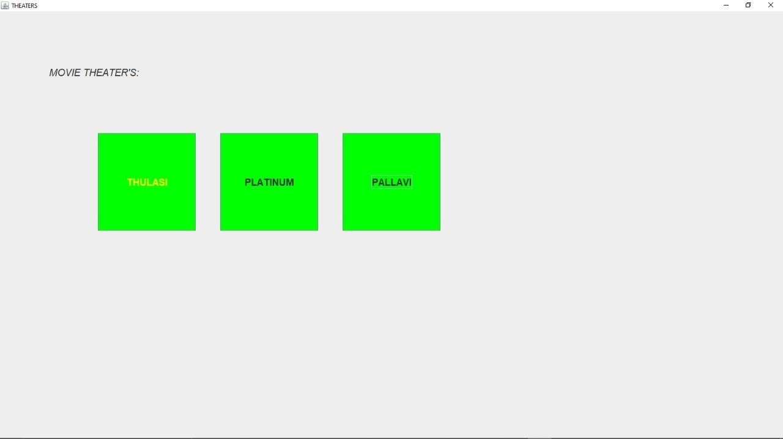

**package booking; import java.awt.Font; import java.awt.event.ActionEvent; import java.awt.event.ActionListener;**

**import javax.swing.JButton; import javax.swing.JFrame; import javax.swing.JLabel; import javax.swing.JTextField;**

**public class Fram implements ActionListener {**

**JFrame j;**

**JLabel l1,l2,l3,l4;**

**JTextField t1,t2,t3,t4; JButton b1,b2,b3,b4; public static void main(String[] args) {**

**new Fram();**

**}**

**Fram()**

**{**

**j=new JFrame("TIMINGS :");**

**j.setVisible(true);**

**j.setLayout(null);**

**l1=new JLabel("SCREEN 1"); l1.setBounds(150, 50, 100, 50);**

**j.add(l1); b1=new JButton("PUSHPA"); b1.setBounds(100, 100, 200,50); b1.setFont(new Font("bold",Font.BOLD,20));**

**j.add(b1);**

**b1.addActionListener(this); l1=new JLabel("6:45 PM, 9:45 PM, 12:30 PM"); l1.setBounds(150, 150, 200, 50);**

**j.add(l1);**

**l1=new JLabel("SCREEN 2"); l1.setBounds(350, 50, 100, 50);**

**j.add(l1); b2=new JButton("ARYA2"); b2.setBounds(300, 100, 200,50); b2.setFont(new Font("bold",Font.BOLD,20));**

**j.add(b2);**

**b2.addActionListener(this); l1=new JLabel("6:45 PM, 9:45 PM, 12:30 PM"); l1.setBounds(350, 150, 200, 50);**

**j.add(l1);**

**l1=new JLabel("SCREEN 3"); l1.setBounds(550, 50, 100, 50);**

**j.add(l1); b3=new JButton("R R R"); b3.setBounds(500, 100, 200, 50); b3.setFont(new Font("times roman",Font.BOLD,20));**

**j.add(b3);**

**b3.addActionListener(this); l1=new JLabel("6:45 PM, 9:45 PM, 12:30 PM"); l1.setBounds(550, 150, 200, 50);**

**j.add(l1);**

**j.setSize(2000, 2000);**

**}**

**@Override**

**public void actionPerformed(ActionEvent p) { if(p.getSource()==b1||p.getSource()==b2||p.getSource()==b3)**

**{**

**Framm.main(null);**

**//JOptionPane.showMessageDialog(j, "ok");**

**}**

**else**

**{**

**}**

**}**

**}**

**package booking;**

**import java.awt.Color; import java.awt.Font; import java.awt.event.ActionEvent; import java.awt.event.ActionListener;**

**import javax.swing.JButton; import javax.swing.JFrame; import javax.swing.JLabel; import javax.swing.JOptionPane; import javax.swing.JTextField;**

**public class Framm implements ActionListener {**

**JFrame j;**

**JLabel l1,l2,l3,l4;**

**JButton b1,b2,b3,b4; public static void main(String[] args) {**

**new Framm();**

**}**

**Framm()**

**{**

**j=new JFrame("BOOKING");**

**j.setVisible(true);**

**j.setLayout(null);**

**b1=new JButton("BOOK TICKETS"); b1.setBackground(Color.LIGHT_GRAY); b1.setBounds(200, 250, 200,200); b1.setFont(new Font("bold",Font.BOLD,20));**

**j.add(b1);**

**b1.addActionListener(this);**

**b2=new JButton("CANCEL"); b2.setBackground(Color.LIGHT_GRAY); b2.setBounds(500, 250, 200,200); b2.setFont(new Font("bold",Font.BOLD,20));**

**j.add(b2);**

**b2.addActionListener(this);**

**j.setSize(1000, 500);**

**}**

**@Override**

**public void actionPerformed(ActionEvent e) { if(e.getSource()==b1)**

**{**

**Frammm.main(null);**

**}**

**if(e.getSource()==b2)**

**{**

**//JOptionPane.showMessageDialog(j, "THANK YOU");**

**Framme.main(null);**

**}**

**}**

**}**

**package booking;**

**import java.awt.Font;**

**import java.awt.event.ActionEvent;**

**import java.awt.event.ActionListener;**

**import java.io.FileWrite**

**r;**

**import java.io.IOException;**

**import javax.swing.ButtonGroup;**

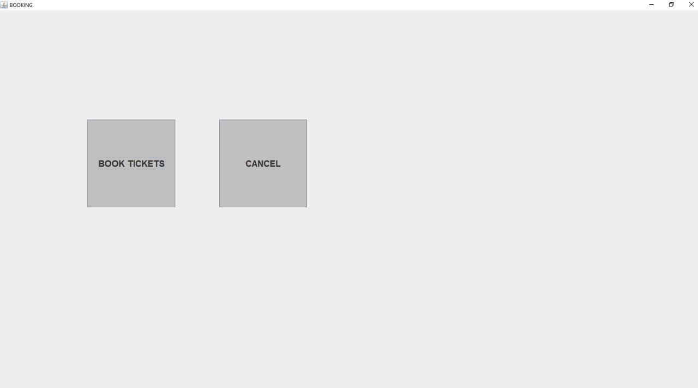

**import javax.swing.JButton; import javax.swing.JCheckBox; import javax.swing.JComboBox; import javax.swing.JFrame; import javax.swing.JLabel; import javax.swing.JRadioButton; import javax.swing.JTextField;**

**public class Frammm implements ActionListener {**

**JFrame j;**

**JLabel l1,l2,l3,l4;**

**JTextField t1,t2,t3,t4;**

**JRadioButton r1,r2;**

**JComboBox cb;**

**JCheckBox c,j1,cpp;**

**JButton b1;**

**ButtonGroup gb;**

**String a[]={"0","1","2","3","4","5","6","7","8",}; public static void main(String[] args) {**

**new Frammm();**

**}**

**Frammm(){**

**j=new JFrame("CUSTOMER DETAILS");**

**j.setVisible(true);**

**j.setLayout(null); l1=new JLabel("mobile no"); l1.setBounds(200, 400, 100, 50); l1.setFont(new Font("italic",Font.ITALIC,20));**

**j.add(l1); t1=new JTextField(); t1.setBounds(300, 400, 150,50);**

**j.add(t1); l2=new JLabel("NAME"); l2.setBounds(200,200,100,50); l2.setFont(new Font("times new roman",Font.BOLD,20));**

**j.add(l2); t2=new JTextField(); t2.setBounds(300, 200, 150,50);**

**j.add(t2); l4=new JLabel("no of tickets"); l4.setBounds(200, 500, 150, 50); l4.setFont(new Font("times new roman",Font.BOLD,20));**

**j.add(l4); cb=new JComboBox(a); cb.setBounds(350, 500, 100, 50);**

**j.add(cb); b1=new JButton("CONFIRM"); b1.setBounds(630, 600, 200, 50); b1.setFont(new Font("times roman",Font.BOLD,20));**

**j.add(b1);**

**b1.addActionListener(this);**

**j.setSize(2000,2000);**

|  |  |  |  |
| --- | --- | --- | --- |
| **}** | **@Override** | **{**                                  **}** | **public void actionPerformed(ActionEvent e) {**  **if(e.getSource()==b1)**    **try**  **{**    **String n=t2.getText();**  **String no=t1.getText();**  **String nt=t3.getText();**  **FileWriter fw=new FileWriter("reg.txt",true); System.out.println(n+" "+no+" "+nt); fw.write(n+" "+no+" "+nt); fw.close();**  **}**  **catch(IOException ie)**  **{**  **System.out.println(ie.getMessage());**  **}** |
| **}** | **}** |  |  |

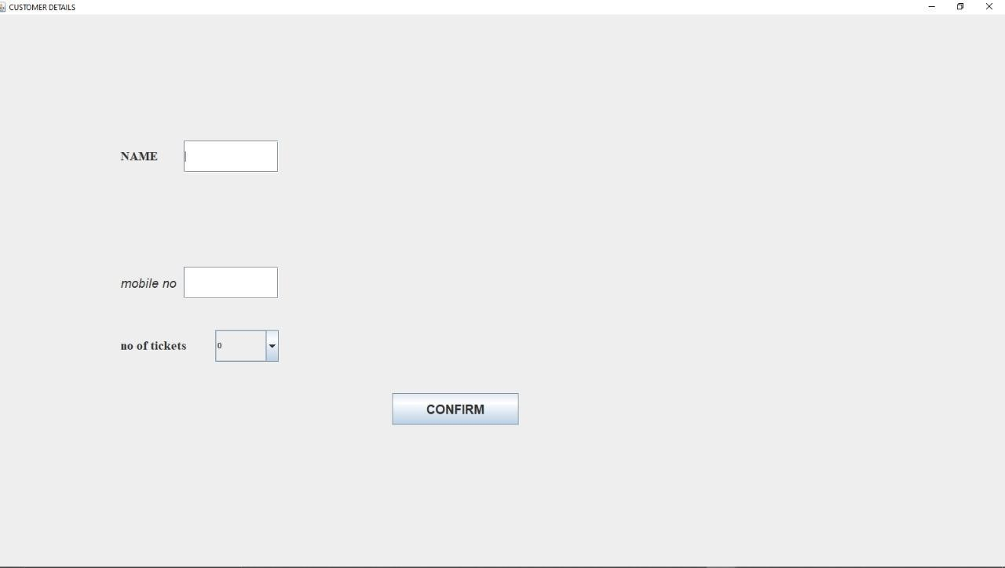

**INTEGRATION AND SYSTEM TESTING**

**OUTPUTS**

**:**

Screen Shots:



**7**

**.**

**CONCLUSION**

**This project is developed successfully and the performance is found to be**

**satisfactory. This project is designed to meet the requirements of assigning**

**jobs. It has been developed in PHP and the database has been builtin My**

**SQL**

**server keeping in mind the specifications of the system. The user will be able to**

**book the ticket using this website. The relationship between company**

**manager, employee, and customer satisfy a good communication to complete**

**ticketing process.**

